

Addis Ababa Institute Of Technology HIC Assignment

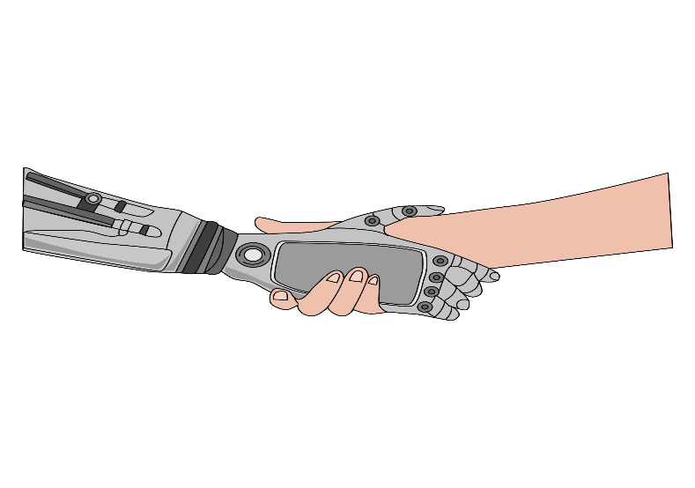 Human In HIC

By: Amanuel Legesse

ID: ATE/3628/11

Submitted To: *Absalat Dawit*

**Assignment 2: Human in HIC**

**1. *Suggest ideas for an interface which uses the properties of sound effectively***

* Using a navigation system with sound embedded to indicate where the user is or what he or she is choosing.
* A confirmation sound like many systems use to let the user know that the action chosen has been carried out.
* An attention seeking sound to let the user be aware or attract his or hers attention for a situation being carried out in the system.

**2. E-commerce has become very successful in some areas of sales, such as travel services, books and CDs, and food. However, in some retail areas, such as clothes shopping, e-commerce has been less successful. Why?**

* From my experience people like buying their items such as clothes in store rather online through Ecommerce because that specific item they are buying needs lots of attention than just purchasing it online, they want to try their outfit if it fits, if it’s the right color for them, there is also the cost of shipment for a retail purchase. The cloud of judgment won’t let them purchase it through E-Commerce they would rather go buy it in stores. That’s why in some retail areas this type of commerce fails to be successful.

**3. Describe ‘forgiveness’ which is one of the characteristics of effective UI.**

* Users usually make mistakes and as a design principle that says people should be able to recover from their inevitable mistakes and that’s where forgiveness comes In giving the choice for the user undo his or hers mistake or even a cancel for a mistakenly chosen action.

**4. Discuss the Long-term memory**

**semantic network?**

* The semantic memory is structured as a network representing the associations and relationships between single items in memory.
* Those single item includes things that are common knowledge, such as the names of colors, the sounds of letters, names of countries and much more.
* The semantic networks theory contends memory is organized in a network of interconnected concepts and certain triggers activate associated memories. These networks are loosely connected conceptual hierarchies linked together by associations to other concepts.

**5. What are mental models, and why are they important in interface design?**

* Mental models play an important role in Human-Computer Interaction. They relate to the way that a user perceives the world around them.
* Mental models help reduce the friction between a user and a user interface.
* The more that a UI matches a user’s model of the world, the easier it will be for the user to the use the UI and get their tasks done that’s why we use mental model when we design an interface.

**5. What can a system designer do to minimize the memory load of the user?**

* You can reduce short term memory load by designing screens where options are clearly visible, or using pull-down menus, notification icons and more.
* The user should not have to remember information from one part of the dialogue
* Recognizing something is easier than remembering it. Minimize the user's memory load by making objects, actions, and options available.